Chapter 5, Problem 16

Using Fig. 5.55, design a problem to help students better understand inverting op amps.
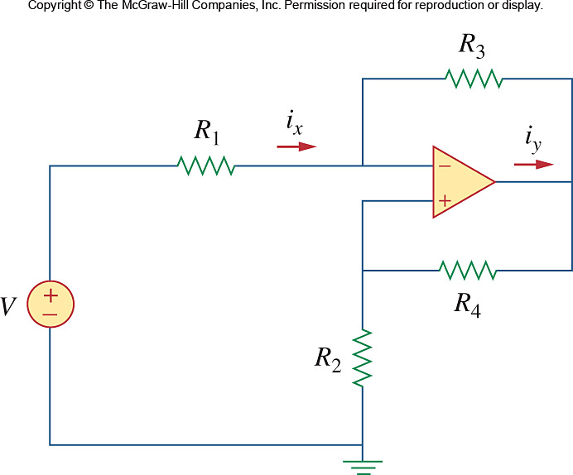

Figure 5.55
For Prob. 5.16.

